DSCI 558: Building Knowledge Graphs

Quiz 18 (5 minutes)

**Question 1: Matching (2pts)**

Match the following Neo4j components to their correct statements.

1. Nodes: Used to represent entities and complex value types
2. Relationships: Have a start node and end node
3. Properties: Used to represent entity attributes and metadata
4. Labels: Used to represent roles

**Question 2: Filling The Blanks (2pts)**

**underlined are blanks**

Write a Cypher query to answer: Johan is learning surfing, and wants to know any friend of his friends who already knows surfing with the following relationships and properties:

* Properties: name, hobby
* Relationships: FRIEND

MATCH (js: {name: ‘Johan’})-[:FRIEND]-()-[:FRIEND]-(surfer:{hobby: ‘surfing’})

RETURN DISTINCT surfer

MATCH (js: {name: ‘____A____’}) - [:FRIEND]- () - [:____B____]-(surfer:{___C___: ‘surfing’})

RETURN ___D___

**Question 3 (2 points):**

Answer the following questions about the following graph:

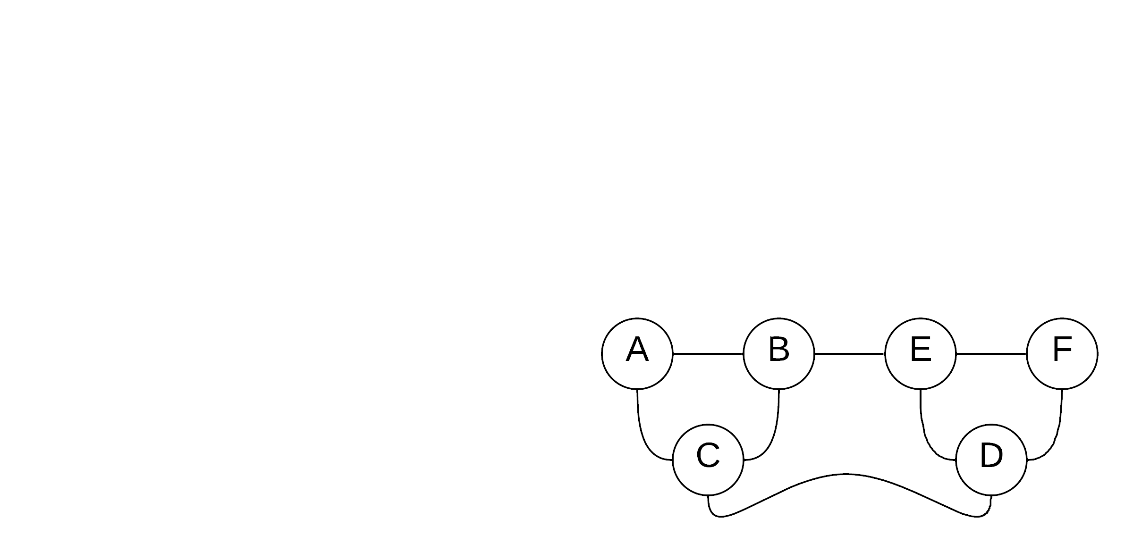

Which node(s) has the highest **betweenness centrality**:

1. B, E
2. C, D
3. B, E, C, D
4. All the nodes

**Question 4 (4 points):**

Calculate the **PageRank scores** (unnormalized) after a **single iteration** for all the nodes in the graph:

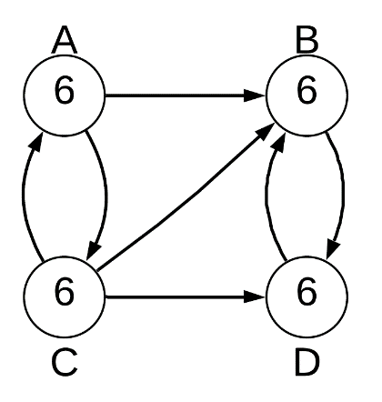

A: _2__

B: _11_

C: _3__

D: _8__